Ministry of Forests
B.C. Wildfire Service

Cranbrook Fire Zone
Briefing Handbook

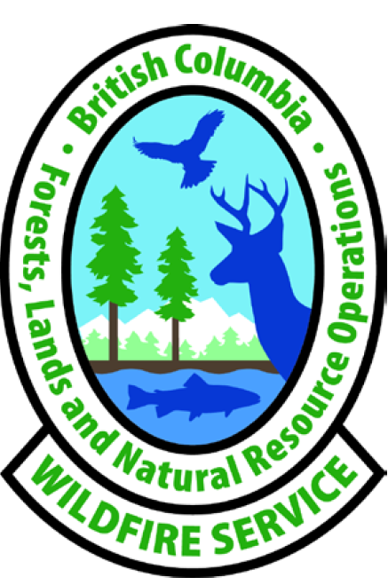



This page left blank

Overview 6
Main Highways 7
Transmission Lines 7
Pipelines: 7
Oil and Gas Facilities: 7
Coal Mines: 7
Railways: 7
Recreation Sites & Commercial Operations: 7
First Nations Communities: 8
High Environment and Cultural Values: 8
Timber Harvesting: 8
Radio Towers and Communication Sites: 8
Wildland Structures: 8
WUI: 8
Range: 8
Community and Domestic Watersheds: 8
BC Parks/Provincial Parks: 8
Climate and fire regime: 8
Fuel Types 9
Interior Douglas fir 9
Lodgepole Pine 10
Ponderosa Pine 11
Zone Map 12
General 13
HP Multi-Functional Device (Printer, Photocopier, and fax) 13
Time Zone 13
WIFI 13
Keys 13
Alarm 13
Places of Interest 14
Landmark Cinemas in the Tamarack Shopping Centre 14
Cranbrook Aquatic Centre (Located in the Western Financial Place) 14
Fitness, Inc – 201A Industrial Road F 14
Anytime Fitness 14
Casino of the Rockies 14
ARQ Mountain Centre (Rock Climbing, Yoga + Fitness) 14
Address and Phone 15
Cranbrook Fire Zone 15
Southeast Fire Centre 15
First Nation Contacts 16
Weather Forecaster 17
Weather Briefings 17
Fire Behaviour Prediction and Forecasting 17
Weather – General 18
Radio Operations and Dispatch Procedures 19
Reporting of Incidents 19
Emergency Procedures 21
Helibase 23
Base Camp Location (Flathead) 24
Prepositioning Locations 25
Agreements/Arrangements 26
Rotation and Assignments 27
Responsibilities (Operations) 28
Access and Lock Up Procedures 29
Administrative Requirements 30
Vehicle Safety 31
Burning Coal Seams 32
Passenger Briefings and Cargo Calculator 33
Appendix 1 – Burning Coal Seams (noted in dispatch as hazards) 34
Appendix 2 - Definitions 36
Appendix 3 – Fire Stages of Control 37
Appendix 5 – Directions to Gray Creek Pass (heading to Kootenay Lake Fire Zone) 38
Appendix 6 – General (Operations) 39
Appendix 7 – Weather Stations 39

Overview

The Cranbrook Fire Zone is generally characterised by hot and very dry summers.

Tree species in the area range from subalpine larch and Engelmann spruce in the high elevation areas to the classic western larch and ponderosa pine forests of the valley bottom.

The zone is composed of two timber supply areas (TSA) - Cranbrook and Invermere.

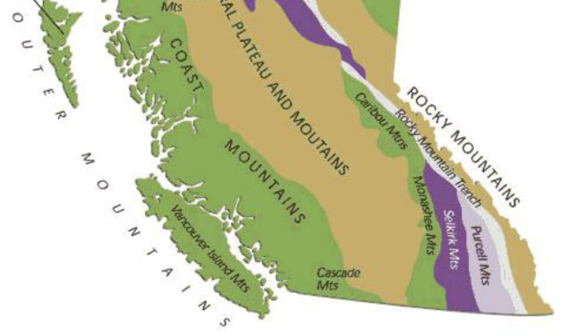
The zone is bounded by the Skookumchuck Valley to the north, the Canada-U.S. border to the south, the Alberta border to the east, and the southern Purcell Mountains height-of-land to the west. Three major physiographic regions characterize the varied terrain of the Cranbrook Zone: The Rocky Mountains in the east, the Purcell Mountains in the west, and the Rocky Mountain Trench in the middle.
The trench varies in width from five kilometers in the north to 27 kilometers near Cranbrook. The western side of the Trench features irregular, comparatively low foothills gradually rising until they merge with the extremely rugged backbone of the Purcell Mountains. In contrast, the eastern side of the trench is characterized by an abrupt rise and continuous wall of mountains broken only by the tributary valleys.

The Rocky Mountain Trench, also known as the valley of a thousand peaks or simply the Trench.

Cranbrook offers many and varied opportunities for recreation and tourism, due to its lakes, parks, and spectacular mountains. The area is well traveled as major highways provide access to Alberta and the national and provincial parks in the Canadian Rockies.

A large percentage of the valley bottoms along the highway corridors in the zone is private land. The range of development includes major cities and towns, smaller communities, concentrated rural development, as well as scattered rural properties, both recreational and agricultural. Potential is high for interface fires along most of the highway corridors.

Provincial Parks located within the zone are the Akamina-Kishinena, Elk Lakes, and Gilnockie, as well as numerous smaller parks and recreation areas and portions of the Purcell Wilderness Conservancy, Height of the Rockies Provincial Park, and Top of the World Provincial Park.
The Cranbrook Fire Zone is a complex land base with various values at risk that can be impacted by wildfires or fire suppression activities.

Main Highways
- Highway 3
- Highways 93,95, & 95A
- Highway 43
- Secondary highways service many of our rural areas

Transmission Lines
- BC Hydro - major and secondary throughout the zone.

Pipelines:
- Fortis BC has a major natural gas pipeline transiting the zone from east to west in the southern part of the zone. It extends from the Alberta border at Crowsnest Pass to the zone boundary with the Selkirk Natural Resource District near Yahk.

Oil and Gas Facilities:
- Two active oil and gas operations, specifically related to coal bed gas. The Green Hills project consists of nine wells and is in the norther Elk Valley coalfield. The Misty Mountain project consists of one well, located within the southern Crowsnest coalfield, and is in the appraisal stage.

Coal Mines:
- Fording River – located 29 Km’s NE of Elkford
- Greenhills – located 8 km’s NE of Elkford
- Line Creek – located 25 km’s north of Sparwood
- Elkview – Located 3 km’s east of Sparwood
- Active burning coals seams (see appendix)

Railways:
- The Canadian Pacific Railway (CPR) has a mainline track that enters the zone from Alberta in the Crowsnest Pass (SE portion of the zone). This line generally follows Highway 3 to Fort Steele where it turns north and follows the Rocky Mountain Trench to Golden and joins the CPR mainline.
- Spur line that extends west to Trail from Cranbrook/Fort Steele and exits the zone along the Moyie River near Yahk.
- Spur lines which service the major coal mines in the Elk Valley. One line runs north to Elkford and beyond to the Fording River operations while a second runs south to Coal Mountain operations.

Recreation Sites & Commercial Operations:
- The zone has an extensive network of recreation sites and trails, there are 107 designated rec sites supporting 567 vehicle sites as well as 66 designated rec trails comprising 481 km of trial. Some are large well-developed sites in the front country, while many are isolated small sites in the back country.
- There are many commercial recreation companies that operate on crown and private lands.

First Nations Communities:
Ktunaxa Nation is comprised of four individual First Nations communities:
- Cranbrook > St. Mary’s ( ʔaq̓am)
- Grasmere > Tobacco Plains ( ʔakink̓umǂasnuqǂiʔit )
- Invermere > Shuswap & Windermere > ( ? Akisq'nuk )
- Lower Kootenay > (yaqan nuykiy) Creston – Kootenay Lake Zone

High Environment and Cultural Values:
- Varying potential for archeological sites or may have First Nations cultural heritage values present.
- Wildlife and habitat areas and Old-Growth Management Areas (OGMA)

Timber Harvesting:
- Two major licensees (Canfor and Galloway Lumber), BC Timber Sales and many small tenures including 30 woodlots.
- Within the zone the current timber supply support 1 Pulp Mill (Skookumchuk), 2 major sawmills (Elko, Galloway)

Radio Towers and Communication Sites:
- Multiple microwave towers, cell phone towers and repeater sites.

Wildland Structures:
- Numerous guide outfitter camps and cabins located throughout the zone and in addition, there are several trapper cabins.

WUI:
- Multiple wildland urban areas

Range:
- Significant range values and livestock grazing leases.

Community and Domestic Watersheds:
- 12 in the zone.

BC Parks/Provincial Parks:
- Several Provincial Parks (7) in the zone (Gilnockie, Akamina-Kishinena, Elk Lakes, Height of the Rockies, St. Mary’s Alpine, Elko, and Top of the World)
- Several BC Parks (11) in the zone (Moyie Lake, Jimsmith Lake, Mount Fernie, Kikomun Creek, Wardner, Crowsnest, Elk Valley, Elko Class C, Morrissey, Wasa Lake, and Norbury Lake)

Climate and fire regime:
- Wide range of climate conditions and complex terrain that supports a varying fire regime across the entire zone.

Fuel Types

Interior Douglas fir
(Best fit FBP fuel type is C7)
Location: Rocky Mountain Trench; West of Lake Koocanusa
This is one fuel that is the most volatile from March to the middle of May, ground fires are much more involved than with Pine stands, this is because deeper duff layers (6-15cm); heavier grass; numerous stumps; denser in growth and more ladder fuels.

Middle of May through to the end of June these fir stands are relatively quiet. The pine grass is quite lush and needle moisture is high. The ground temperatures are cool and moisture loss is slowed down due to the stands density which blocks the wind and direct sunlight. When we do get fires in this stand, it usually is confined to the base of larger trees and in and around old stumps.

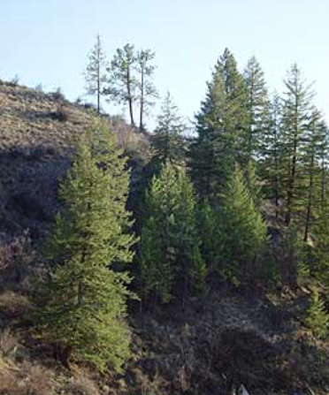
Early July and well into September, fire behaviour changes dramatically for the worse.

During high temperatures which can easily reach 30+ C; low afternoon RH’s (15-20%) surface fires quickly engulf the entire thickets and either eliminate them entirely or reduce the site significantly. The potential for large scale candling is high and total crowning is possible. Spotting occurs frequently when these thickets suddenly “explode” and send burning needles ahead of the fire front. Fire control is always difficult as fire intensity will often simply vaporize water. Retardant lines are often not effective unless immediately reinforced with crews.

Mid-September through to the first snow (Oct/Nov) fire behaviour drop dramatically and act more like springtime fires.

The Interior Douglas-fir (IDF) zone surrounds the PP zone in the East Kootenay, covering much of the Rocky Mountain Trench as far north as Golden. Zonal sites in the IDF typically have pure stands of Douglas-Fir, or mixed seral stands of Douglas-Fir, Western Larch, and Lodgepole Pine. Surface vegetation is dominated by Pine grass and shrubs.

Lodgepole Pine
(Best fit FBP fuel type is C5)
Location: Rocky Mountain Trench; East of lake Koocanusa
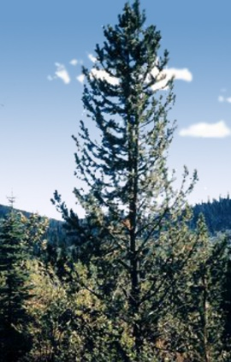
July through to September, as the area undergoes its greatest drying period the Pl stands become very volatile and tend to “run and candle”.

When major candling or crowning takes place the volume of heated needles can be quite heavy; spotting can be anticipated well in from the fire’s head. Pl pine is thin barked and can suffer mortality at much less severe fire intensities.

From the time the snow leaves to approximately mid-May even low intensity fires have an ability to seriously impact these stands.

Mid May to the end of June not much fire activity takes place in these stands, because of general weather conditions and fuel moisture rather than the Pl pine’s ability to the resistance of fire.

Ground application of foam on the flanks will usually hold them until equipment arrives on site. Although a hand guard will often suffice as the duff layers are minimal (4-10cm). Retardant will be effective when dropped in the more open canopied areas. Fires in these types generally lose their steam come sundown, as the fine fuels quickly absorb moisture and there are not enough continuous larger fuels to provide any heat source.

From the end of September until late October or nearly November these stands usually react much as they did in the spring.

The Montane Spruce (MS) zone occurs on the mid-slopes of the Rocky Mountain Trench and the Rockies south of Golden, and the eastern Purcell Mountains south of the Spillimacheen River. Generally, the best-fit fuel type is C5.

The Engelmann Spruce – Subalpine Fir (ESSF) zone occurs at higher elevations (above the MS or ICH) throughout the region. Closed canopy forests of Engelmann Spruce and Subalpine Fir are common at the lower and middle elevations in this zone. At upper elevations, subalpine parkland consisting of tree islands interspersed with herb-dominated meadows is common. Seral Lodgepole Pine stands are common in areas with a frequent fire history. Deciduous trees are uncommon in the ESSF. Generally, the best fit FBP fuel type is C5.

Ponderosa Pine
(Best fit FBP fuel type is C7)
Location: Southern Rocky Mountain Trench

Burning characteristic vary widely during the snow free period (March-November). Typically for March, April, and early May, prior to “green up”, low intensity fire or prescribed burns have little impact on the overall stand.

Mid May through to the end of June; when grass, shrubs and needle production is at its greatest and live fuel moisture are high, these stands only rarely experience any fire activity at all. These fires tend to sit and smoulder and even with strong winds, high temperatures and low afternoon RH do not appear to have much influence on them.

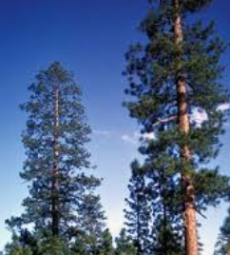
Beginning around early July through the middle of September these stands display increasingly severe fire Behaviour characteristics.

It is common for temperatures to be +30C, and RH to bottom out in the teens and of course the winds that we experience in these areas, often wind gusts reach 15-30km. Intense surface fires are experienced; some fires will take out entire Py thickets and even severely scar the older trees. The entire duff layer may be involved and is often destroyed. With sparse ground fuels and open crown canopies, air tankers are very effective in containment. Mop-up is also relatively easy as most of the duff is eliminated. Almost anything will suffice for guard construction, manmade fuel breaks such as fence lines and roads. Quite often we simply pull back to these breaks or natural openings and burn off.

From the middle of September through to first snow, fire Behaviour characteristics are like that of the early spring with the exceptions that larger dead fuel will often burn completely out due to high drought code.

The Ponderosa Pine (Py) zone is restricted to the driest sections (valley bottoms) of the southern Rocky Mountain Trench, north of Cranbrook and on the southeast side of Lake Koocanusa. Open stands of Ponderosa Pine are common on zonal sites. Grasses dominate the surface vegetation

Zone Map

50 35.099’, -115 01.405’

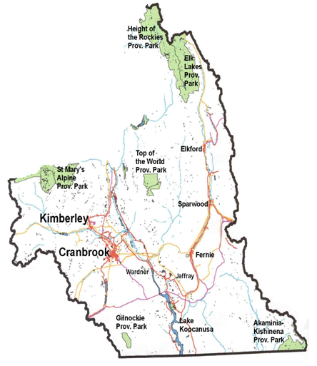 USA
49 00.124’, -115 43.737’

49 01.597’, -114 03.274’

49 38,777’, -116 40.818’

ALBERTA

General

HP Multi-Functional Device (Printer, Photocopier, and fax)
The printer is in the main office building.
P11075PS, P11075 fax (without FOB)

Time Zone
Mountain Daylight Time (MDT) and in the fall Mountain Standard Time (MST)

WIFI
The zone is fully equipped with WIFI capability and is available with two networks:
Dogwood Guest access provides internet access but no access to the network and no password required, although you will need to accept the terms each time you log in.
BCNGN Can be logged in using your IDIR account and password and provides internet access as well as network access.

Keys
The Zone uses different keys around its facilities. If you will require access to the facilities outside of regular business hours, ensure you have been assigned a Key Set from the Operations Assistant.

Alarm
All buildings are equipped with an alarm system. Each building needs to be disarmed and armed independently. If you will require access to the buildings, including the warehouse after house please ensure you have been assigned an alarm code from the Operations Assistant. There are also contact numbers adjacent each keypad in the event there is an issue with the alarm.

Address and Phone

Cranbrook Fire Zone
Address
2550 Stahl Rd.
Cranbrook, BC V1C 7B1

Zone Wildfire Coordination Officer 250-420-6179
Operations Assistant (front desk) 250-420-6170

Direct Lines ( MZOC activated )
Plans – 250-420-6182
Logistics – 250-420-6183

Appendix 4 - General

Staffing numbers

Ops Asst. | Asset Mgmt Assistant | Full time Staff | Seasonal  Wildfire Assistants | Seasonal IA Crews  (3 Person crew) | Seasonal Unit Crews (20 Persons) | Fire Wardens
1 | 1 | 5 | 2 | 5 | 2 | 7

Southeast Fire Centre
Mailing Address:
Ministry of Forests, Lands, Natural Resource Operations and Rural Development
Southeast Fire Centre
208 Hughes Road, Castlegar BC
V1N 4M5
Reception: (250) 365-4040
Location: West Kootenay Regional Airport – Airport Rd.

First Nation Contacts

ʔaq̓am (St. Marys Band) Reserve
Joe Pierre Jr. - Chief
250-417-1491
Jason Andrew - Councillor
250-919-1925
Michelle Shortridge – Director of Operations / Community Services
250-420-1083

Tobacco Plains

Weather Forecaster

The Southeast Fire Centre weather forecaster provides a daily fire weather forecast along with a list of all current weather stations for the fire centre; our specific Wx zone is 27. The weather forecaster prepares spot forecasts, and various advisories.

The Southeast Fire Centre dispatch will notify field staff by radio broadcast of any weather warnings, fire behaviour advisories and extreme fire behaviour warnings.

Weather Briefings

These briefings are scheduled every Monday and Thursday at 10:15am Mountain Time and are approximately 15-20 minutes.

The weather briefings may also take place daily if deemed necessary by the Regional Wildfire Coordination Officer.

Fire Behaviour Prediction and Forecasting

A Fire Behaviour Specialist (FBS) on standby for the fire centre can provide technical expertise for tactical operations to support the safe and effective use of fire suppression and management resources.

Specific services offered by the FBS include developing fire projection maps, interpreting weather forecasts, and performing fire growth modeling
Short-term (1-3 days) fire growth projections can be done.
Long -Range Fire Growth Projections and PFAS modeling can be done but usually requires the support of other specialists, including weather forecasters.
PFAS (Probabilistic Fire Analysis System) projections are usually requested from the Advanced Planner at the PWCC and can usually be received within 1 day of request.

Weather – General

Although the weather predominately comes from the west, most valleys run north/south. This provides for differential precipitation on the windward and leeward (subsidence) sides of mountain ranges. Consequently, the western slopes receive more precipitation than the eastern slopes, which are basically in a rain shadow.

The terrain also significantly influences the wind direction and speed. Wind tends to be funnelled through the main valleys, changing direction as valley orientation changes, and increasing in velocity when constricted by terrain.

Typically, because of daytime heating, wind generally increases and travels up-slope and up-valley during the daytime. As the sun sets, the winds typically abate and switch to down-slope and down-valley. This diurnal process is consistent and predictable within the region, and often means that burning conditions are lessened during the nighttime.

Koocanusa (C7) | Elko (C7)
Flathead 2 (C7) | Negro Creek (C7)
Dewar Creek (C5) | Cranbrook FS (C7)
Goathaven (C7) | Sparwood QD2 (C7)
Round Prairie (C7) | Cherry Lake (C7)
FBP Fuel types that best represents the zone are C5 and C7 (Red and White Pine, Ponderosa Pine-Douglas Fir)

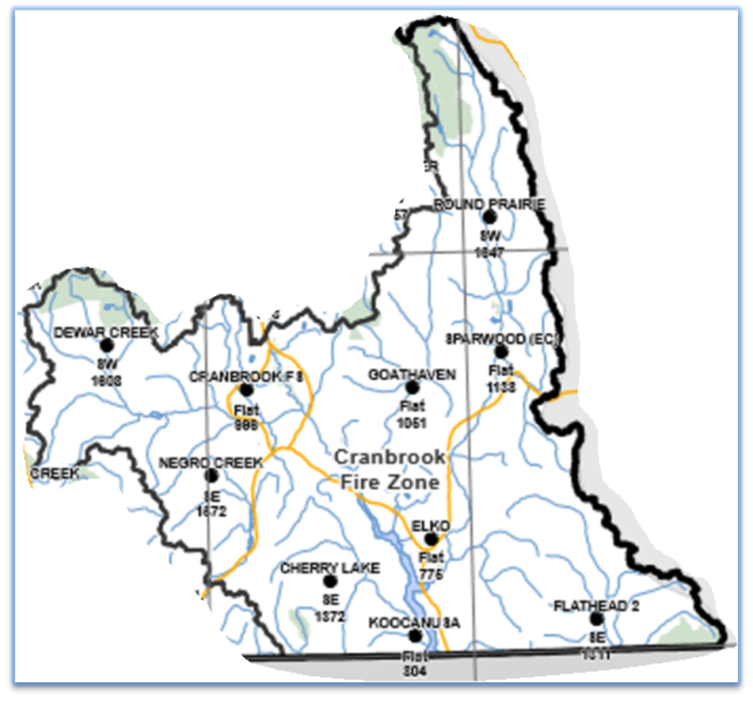
Prevailing winds → from the South / Southwest

Thunderstorms typically arrive from these directions and rains associated with thunderstorms are often patchy, weather station readings may not be representative of rain in surrounding areas.
In the summer months it is not uncommon to see localized winds blow 10-20 km throughout the day and for days on end.

Radio Operations and Dispatch Procedures

Reporting of Incidents
All incidents are reported directly to the Southeast Fire Centre where an incident number is created.
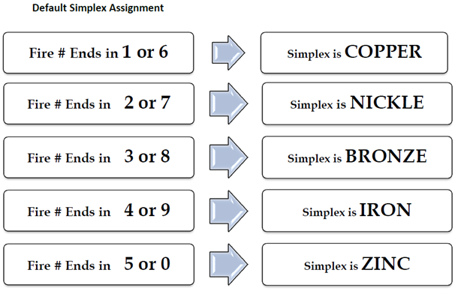
Default Simplex Assignment
Once an incident number is created, all assigned and responding parties will be able to reference the guidance provided below to ensure clear communications. The simplex assignment can be overridden in circumstances where warranted at the discretion of the Incident Commander. If this takes place the IC is responsible to notify the assigned resources, incoming resources immediately of the change.

Safety Check-In/Out Procedures
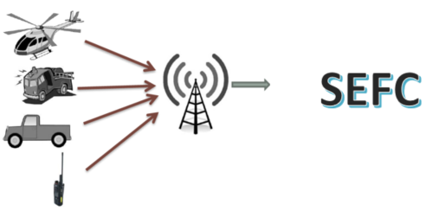
You will be required to check-In/Out with the Southeast Fire Centre. When field work is related to wildfire response, radio is the preferred method of communication. Ensure to set up a check-in schedule with dispatch.
SEFC Dispatch 250-365-4001/or 778-364-1242. Refer to the repeater map on the next page to ensure you are using the correct repeater and tone.
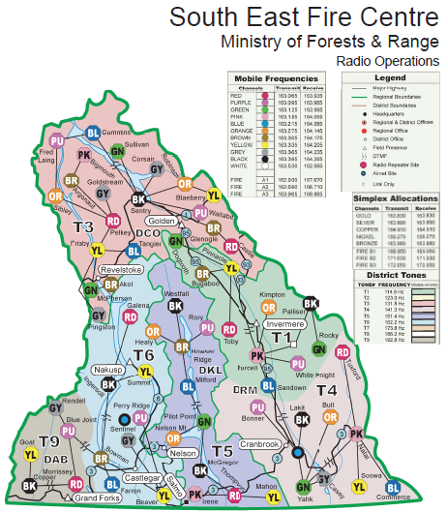
Zone repeater channel Ch 10 – Tone 4 and simplex channels
CHANNEL | COLOR | FREQUENCY | TONE | TX | RX
10 | BLACK | 141.3 Hz | T4 | 163.395 | 164.265
OFC 1 |  | 155.460
OFC 2 |  | 150.350
SIMPLEX |  |  | CHANNEL | TX | RX
 |  |  | GOLD | 163.830 | 163.830
CPR Primary channel is Silver  Fire Departments Alternate is Silver |  |  | SILVER | 163.890 | 163.890
 |  |  | COPPER | 164.910 | 164.910
 |  |  | NICKEL | 159.270 | 159.270
 |  |  | BRONZE | 163.980 | 163.980
Refer to the Radio Communication Field Handbook

Emergency Procedures

Police Departments

Cranbrook
Emergency 911
Administration 250-489-3471

Kimberley
Emergency 911
Administration 250-427-4811

Fernie
Emergency 911
Administration 250-423-4404

Fire Departments
Emergency call 911

Non-Emergency numbers listed
Cranbrook Fire Department
Phone: 250-426-2325
Kimberley Fire Department
Phone: 250-427-3473
Sparwood Fire Department
Phone: 250-425-0558
Fernie Fire Department
Phone: 250-423-4226
Jaffray Fire Department
Phone: 250-429-3133

Other departments in our zone include:

Elkford FD, Hosmer FD, Baynes Lake FD, Elko FD and do not have non-emergency numbers listed.

No Coverage in these areas
Fort Steele, Grasmere, Moyie, New Gate

*Memorandum of Agreement for Inter-Agency Operational Procedures and Reimbursement Rates
This operational procedure document will ensure that there is an understanding of roles and responsibilities for wildfire and wildland urban interface fire response between the Office of the Fire Commissioner, Fire Chiefs Association of BC representing all local governments fire departments and the BC Wildfire Service.

It is anticipated that when BCWS and a fire department work mutually on a wildfire event, a command structure will be maintained within a spirit of "Unified Incident Command" through the duration of the event.

Medical and Hospital
Ambulance: Emergency 911 Business 250-426-8944

Hospitals
East Kootenay Regional Hospital 250-426-5281
13 – 24 Ave N, Cranbrook BC
24 hr. Emergency Room – Phone: 250-420-4160

Type: Heliport
Latitude: 49°.30’42” N
Longitude: -115°.44’59” W
Elevation: 3050 feet

Phone ER Nurse w/injury type & ETA for Heli clearance – Phone: 250-489-6476
*Only twin engine – Currently H1 may become H2, this means that only intermediates or mediums to land.

Fernie (Elk Valley Hospital) 1-250-423-4453
1501 – 5th Ave Fernie BC
Heliport: 49 30.00 x 115 04.01
Elevation: 3300 Ft

Calgary Foothills Hospital (Major Trauma) 1-403-944-1110
Communicate with SEFC dispatch or the Operations Officer
Emergency Room Phone: 403 944-1315
Type: Heliport
Latitude: 51°03’55” N
Longitude: -114°.08’06” W
Elevation: 3635 feet

Helibase

Emergency Use only (if Airport can no longer accommodate)

Location: Overpass Wrecking Ltd – (Large grassy field)

Latitude/Longitude: 49.32.244 x 115.44.832

Legal: Parcel 11, PL 3310 – I / Parcel 7 PL 33310-1

Directions from the zone office: (2 mins) head south towards town, turn right on 22nd St N (set of lights near Lordco), turn a right on Zimmer Road (just past transfer station and avoid the driveway for B.A. Asphalt & Concrete). Very close to the zone office.

Water: Joseph Creek located east of the field; potable water is not available.

Power: No power, generators only.

Telephone: No telephone on site but cell phone reception is excellent.

Communications: Channel 10 – Black - TX 163.395 Rx 164.265

Hazards: Various power lines, businesses, and homes in the vicinity.

Fuel: Drummed fuel in fuel berms can be arranged for the short term until the fuel bowers arrive.

General: The area is a large grassy field; deciduous trees located to the east of the property and the main septic system for the city is located to the north. The land is privately owned, and the contact information is in the zone office.

Other Considerations: During the summer months this field becomes very dry and dusty; a water tender should be onsite for dust control. Notify the tenants during the set-up stage. There is a flagpole on site, recommend a windsock to be installed. Two portable office buildings along with two portable outhouses will have to be ordered. There is a designated parking area available for staff. There is a garbage disposal facility located across the street.

Note: Land use agreement is required prior to landing any aircraft at this location. Check with the zone office or Air operations at the Southeast Fire Centre.

Butts Cabin – Flathead Valley

Location: Butts Cabin – Remote area in our zone
Butts Cabin Recreation cabin and a storage shed is on site, the site is still known as Butt’s Cabin. See Appendix 4 -page 37 for map. Logistics is difficult for this area due to the location

Coordinates:
49° 07.130 x 114° 30.560

Directions from the zone office:
Take highway 3/93 towards Elko, at the Elko General Store (Hwy 3) hit your trip meter and drive approximately 15.5 km and turn onto Morrissey Road (right turn).

Continue over the elk river bridge and CPR tracks, turn right, and stay on the Morrissey FSR (20Km), do not take the lower road that parallels the tracks (Domin Rd).

You will come to a Y in the road (17Km), keep to the right and stay on the main FSR, the Morrissey FSR will turn into the Lodgepole FSR (16Km). Do not turn right onto the River Rd FSR.

While on the Lodgepole FSR, at the 25 km stay to the left, at the 42.5 km stay to the right (McLathchie/Lodgepole Jct.) at the 57.9 km you will see the Sasquatch Junction sign - stay to the right, at the 74Km turn right (Flathead/Akamina Kishinena Rd), drive till you see Butts Cabin Rec Site (approx. 1Km)

Water: bottled water only or potable water unit (do not drink out of the old well site)
Power: No
Telephone/cell coverage: No and No cell phone reception
Communications: Channel 5 – Blue - TX 163.215 Rx 164.085
Hazards: Well site
Fuel: Drummed fuel in the storage shed adjacent to the recreation cabin.
Portable fuel berms will be needed if the fuel is taken outside the building.
First Aid: Level III stretcher kit located inside the storage shed (covered kit inside a wooden box).
Access to the storage shed: A “P” key is required for access. There is one small recreation cabin adjacent, which is often occupied by recreationalists.
Outhouse: One located to the west of the cabin
Another recreation site is located across the road to the east with an outhouse and camping area.
The recreation cabin is not locked, it is left open to the public.

Other Considerations:
There is a large field approximately 1.5-2 km south on the FSR that can be used to set up a fire camp and has a well on site.

Prepositioning Locations

The SEFC Operations Officer or the Zone Wildfire Coordination Officer may pre-position resources when a quick response is required to implement the appropriate management response for potential natural or human caused ignitions. Three pre-positioning locations are listed below:

Day Base Locations
Name | Geographic | Lat. | Long. | Facility | Radio Freq.
Lake Koocanusa | South Country | 40.12.00 | 115.12.11 | Dirt | Gray (Ch 9)
Butt’s Cabin | Flathead | 49.07.190 | 114.30.454 | Fuel shed, small cabin & Field | Blue (Ch 5)
Ascent Helicopters | Fernie  549 Burma Road | 49 30.413 | 115 4.595 | Base | Pink (Ch 4)

Agreements/Arrangements

Equipment Rental Agreements (ERA’s):

If you require heavy equipment, contact the ZWCO or the Operations Assistant.

! IMPORTANT

Top 10 list of companies signed up in the spring and they will be first priority for call outs.

Standing Arrangements

These services are available, if requesting please contact the ZWCO.

- Fire Crew Type II and Fire Crew Type III

- Structure Protection Crew and Structure Protection Unit Services (SPC_SPU)

- First Aid

- Catering, Laundry & Janitorial

- Danger Tree Assessing and Falling Services (DTAF)

- Falling Coordinator and Danger Tree Specialist Services (FCDTS)

- RPAS Wildfire Infrared Scanning (Remotely piloted aircraft system – Drone)

Rotation and Assignments

The rotation schedule/Assignments are set for each prep period; it will be at the discretion of the Zone Wildfire Coordination Officer or the MZOC director to fit you into this schedule.

As for other resources you will be notified of your alert level, work hours, standby hours, and assignments.

Red Alert – ready to depart from a pre-determined staging point (zone office or designated location)
Yellow Alert – ready to depart within 30 mins

Standby (Mins, Mods, Maxs)
Please refer to the SEFC RWCC Standby document

Zone Wildfire Coordination Officer has a mandate to act in anticipation of fire problems, as well as to coordinate all fire control resources at his/her disposal within his/her jurisdiction.

Provincial Wildfire Coordination Officer in consultation with the Regional Wildfire
Coordination Officer, sets fire control priorities within the province, controls the strategic
deployment of fire control resources to the centres, including any uncommitted resources
within the province.

Regional Wildfire Coordination Officer sets fire control priorities within the centre,
controls the tactical deployment of fire control resources to the zones, including any
uncommitted resources within the centre, deploys I. A. resources on a priority basis to
specific fires.

When working specific fires, staff will retain contact with a Fire Centre who will keep
them advised as to their specific duties and targets. The Incident Commander has control
over resources assigned to a specific fire.

Response Officer Refer to the Response Officer (RO) R&R document.

Responsibilities (Operations)

10 Operational Safe Work Standards

OSWS 1 – Wildfire Dangerous Trees
OSWS 2 – Staff Health and Fatigue Management
OSWS 3 – Heavy Equipment Operations on the Fireline
OSWS 4 – Fire Entrapment Avoidance
OSWS 5 – Fire Behaviour Advisories & Warnings
OSWS 6 – First Aid Coverage and Crew Configuration in Remote Work Areas
OSWS 7 – Emergency Transportation by Aircraft and Aviation Manifests
OSWS 8 – Hydrogen Sulphide and Geophysical Operations
OSWS 9 – Conducting Planning Ignitions
OSWS 10- Hiring Personnel under the Age of 19

Fire Rehabilitation:
The Zone Wildfire Coordination Officer will provide you the point of contact for the Ministry of Forests, Lands and Natural Resource Operations, Rocky Mountain Resource District (DRM) @ 1902 Theatre Road.

Fire Analysis:
Fires that cannot be safely actioned in a timely manner or are either limited action or modified response, we should be striving to provide a FA within 72 hrs. The Fire Analysis guides the decision-making process to balance the values at risk with suppression expenditures. The Zone Wildfire Coordination Officer will be your point of contact if required.

Fire Management Plan:
Response based fire management plans provide wildfire responders with valuable information that assists with reduced damage to values on the land base and cost-effective and efficient fire suppression. The plan is to be used as aids to the decision-making process for wildfire prioritization and suppression, and in the development of the fire analysis. (Refer to the Rocky Mountain Resource District Fire Management Plan)

Overnighting:
The Regional Wildfire Coordination Officer and the Zone Wildfire Coordination Officer will determine if it is required. Always be prepared to overnight.

Air Support (Air tankers/Helicopters):
When you make a request for air support, ensure you have a clear achievable objective and you have discussed this with the operations officer and the zone wildfire coordination officer.

Access and Lock Up Procedures

The buildings are set up with an alarm system, you may be assigned a 4-digit access code/password to access the buildings along with a set of keys.

The keys are engraved with the following letters for identification purposes.

BG - Key – main base gate
P - Key – opens several gates throughout the zone
WH Key – opens the two zone warehouses
B - Key – main offices, the crew ready room and certain sea containers
3303 – access to the fuel sheds and sea containers

Alarm Pads
Used to activate and deactivate the alarm system.
- Go to the nearest keypad, (no movement when setting it)
- Enter your 4-digit code on the keypad, no other buttons required
- You will have 2 min to get out of a building.

If the alarm goes off - immediately call API @1-800-268-6870

Give them the Account No. (Posted on the sheet below the keypad)
Your name and your 4-digit code/password.

Administrative Requirements

It is your responsibility to ensure that all your finance and administration duties are completed in a timely matter.

The Finance and Administration manual commonly referred to as the “Green Book” is available.

A few common Forms/Reports

- Field Safety Plans
- Daily Time Reports
- Contractor Performance Evaluation
- Contractors Daily Time Reports
- Incident Reviews
- WorkSafeBC Forms (FS322A, Form 7)
- Passenger and Cargo Calculator (PACC)
- iExpense & Travel Voucher
- Daily Estimated Costs reported to the office (DEC’s)
- Field Fire Report Notebook

BC Wildfire Service Safety Incident Report is required for all incidents

This is a document used to report, investigate, and track any safety incident or accident that occurs in any BC Wildfire Service operations.
Refer to BC Wildfire Service Incident Reporting and Investigation Instructions.

Vehicle Safety

If you are involved in or arriving at the scene of an accident, proceed as follows:

Notify the SEFC immediately via radio or cell phone and you may use the 10-50 code

Code 10-50 means you have been dispatched/witnessed a potential accident scene. Aircraft may or may not be involved. You are to assume that all persons involved are alive, injured and burned.
DO NOT mention names over the radio. Request ambulance and police as situation dictates. Remain at the scene until the police and ambulance arrive.

In the event of a critical incident, immediately notify the ZWCO

BC Forest Service Roads Radio Protocol
Drivers with a radio should call the following if a frequency is posted unless a sign indicates otherwise.

When: starting, stopping, entering, or leaving a road, at “must call” signs, every km or every 2 km if no oncoming traffic, “up” with increase or “down” with decrease in km signs, in order of road name, km, up/down, number of vehicles. No call if part of convoy called by lead vehicle within 1 km.

Lead vehicle must call for all vehicles in a convoy, vehicles joining or leaving the convoy must notify and receive confirmation from the lead vehicle.

Always use headlights and drive according to conditions, particularly hazardous ones such as dust, soft sub grade, or rainstorms. Always adhere to speed limits and expect and prepare for the unexpected.

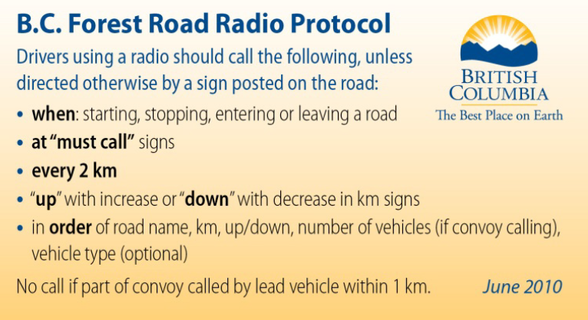

Burning Coal Seams

These coals seams are located in the northern part of the zone (Elk Valley).

For your safety and others please Do Not action any fires near a burning coal seam until you have spoke with the Zone Wildfire Coordination Officer

Burning Coal Seams
Aldridge Creek | 50° 19.513 | 114° 53.462
Coal Creek | 49° 29.589 | 114° 59.465
Sparwood | 49° 43.550 | 114° 52.488
Michel Creek | 49° 43.00 | 114° 52.00 | Approximately located on Elkview Coal
Sparwood | 49° 42.322 | 114° 52.006 | Coal seam # 6 on dispatch, east of Sparwood
Elkview Mine | 49° 44.490 | 114° 48.214 | Coal seam # 5 on dispatch, between Bodie cr. and Erickson Creek – east of Elkview mine
Sparwood | 49° 42.029 | 114° 51.464 | Coal seam # 4, south of coal seam # 6, located on dispatch
Lodgepole | 49° 42.029 | 114° 51.464 | Lodgepole coal seam – east of 21Km marker on Lodgepole FSR. # 4 on page 33.
See photographs – Appendix 1

Passenger Briefings and Cargo Calculator

Passenger Briefings
The pilot in command is responsible to ensure that all passengers are provided a full safety briefing prior to each flight. This is particularly important in the unique conditions encountered during BCWS flights.

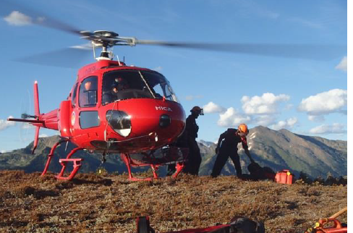
Passenger and Cargo Calculator (PACC)
The representative responsible for the flight (e.g., the Crew Leader, Wildfire Officer, single resource, etc.) is responsible for providing the pilot with a completed PACC sheet. This form will include accurate passenger call signs and weights, itemized equipment cargo list and weights, and a total payload weight tally.

The representative must also advise the pilot of any dangerous goods being transported. The PACC must be completed and communicated to the pilot for all flights.

The passenger manifest as well as the full payload weight must be communicated over the radio at the beginning of every flight.

Appendix 1 – Burning Coal Seams (noted in dispatch as hazards)

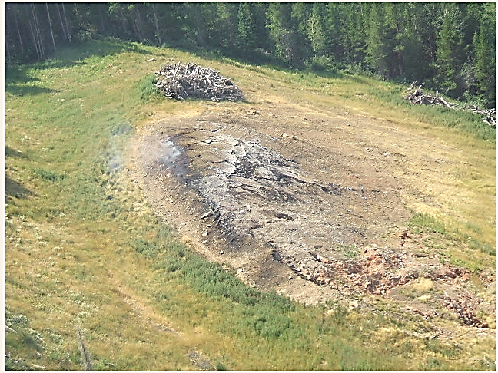
Aldridge Creek (1)

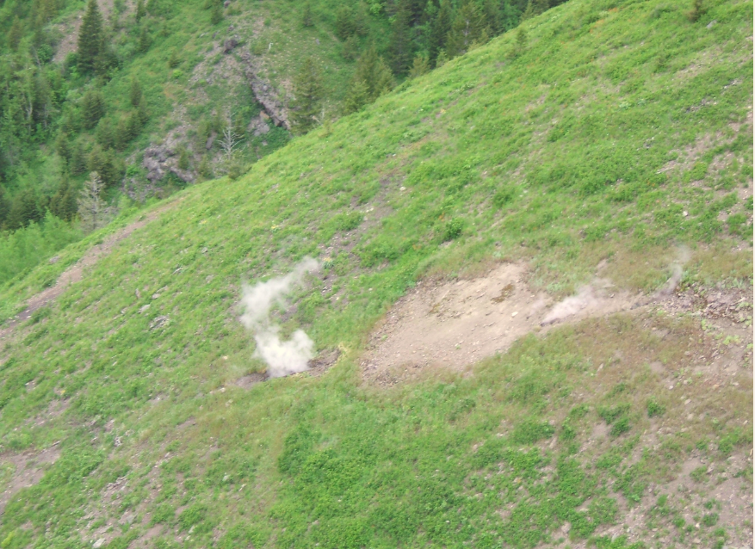
Coal Creek (2)

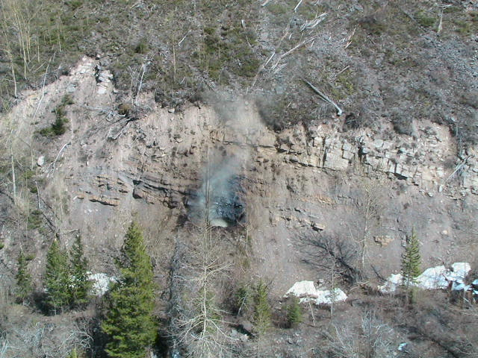

Sparwood (3)

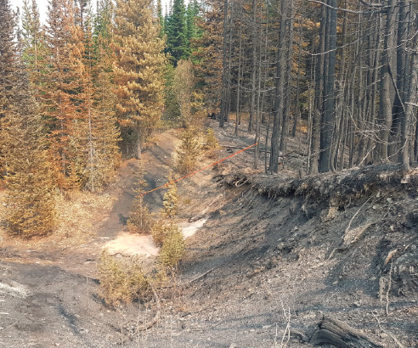

Coal Seam (4) East of the 21 km marker on the Lodgepole FSR

Appendix 5 – Directions to Gray Creek Pass (heading to Kootenay Lake Fire Zone)

map

Appendix 6 – General (Operations)

MZOC – Ministry Zone Operations Centre

An MZOC is activated as required for a specific geographic area with authority from RWCC. There would be 3 levels or types of MZOCs that may be activated depending on need and role: type 3 expanded logistics support; type 2 coordination and assignment of specific resources and/or specific functions; type 1 full coordination, dispatch, and use of assigned resources operating more like a RWCC but still reporting to the RWCC.
ZWCO – Zone Wildfire Coordination Officer

Zone Wildfire Control Officer - is responsible for fire management in the zone.

The ZWCO has three levels of recognition and responsibilities:

ZWCO 3 – Responsible for field logistical coordination and support
ZWCO 2 – Expanded operational, planning, and financial responsibilities as delegated by the RWCO to the ZWCO for the Area of Responsibility.
ZWCO 1 – All RWCC responsibilities formally delegated by the RWCO to the ZWCO for the Area of Responsibility.

RO - Response Officer

Single resource identified and ready to be dispatched to a local area to respond to an incident. The RO may or may not become the IC but could be involved in wildfire cause & determination investigations, wildfire prioritization or other functions in support of wildfire activities.
ICS structure implemented as required.
Fire Origin and Cause investigations and Enforcement
BCWS is responsible for determining the origin and cause of wildfires on Crown land and assess all wildfires that it responds to. The RWCO has the authority to decide the need for a BCWS fire origin and cause investigation. For fires where there is a suspected contravention, the BCWS and the Compliance and Enforcement Branch will follow the joint enforcement process. BCWS will notify the CEB of all human-caused wildfires, the CEB conduct the investigations and enforce compliance.

Appendix 7 – Weather Stations

